 |  |  | 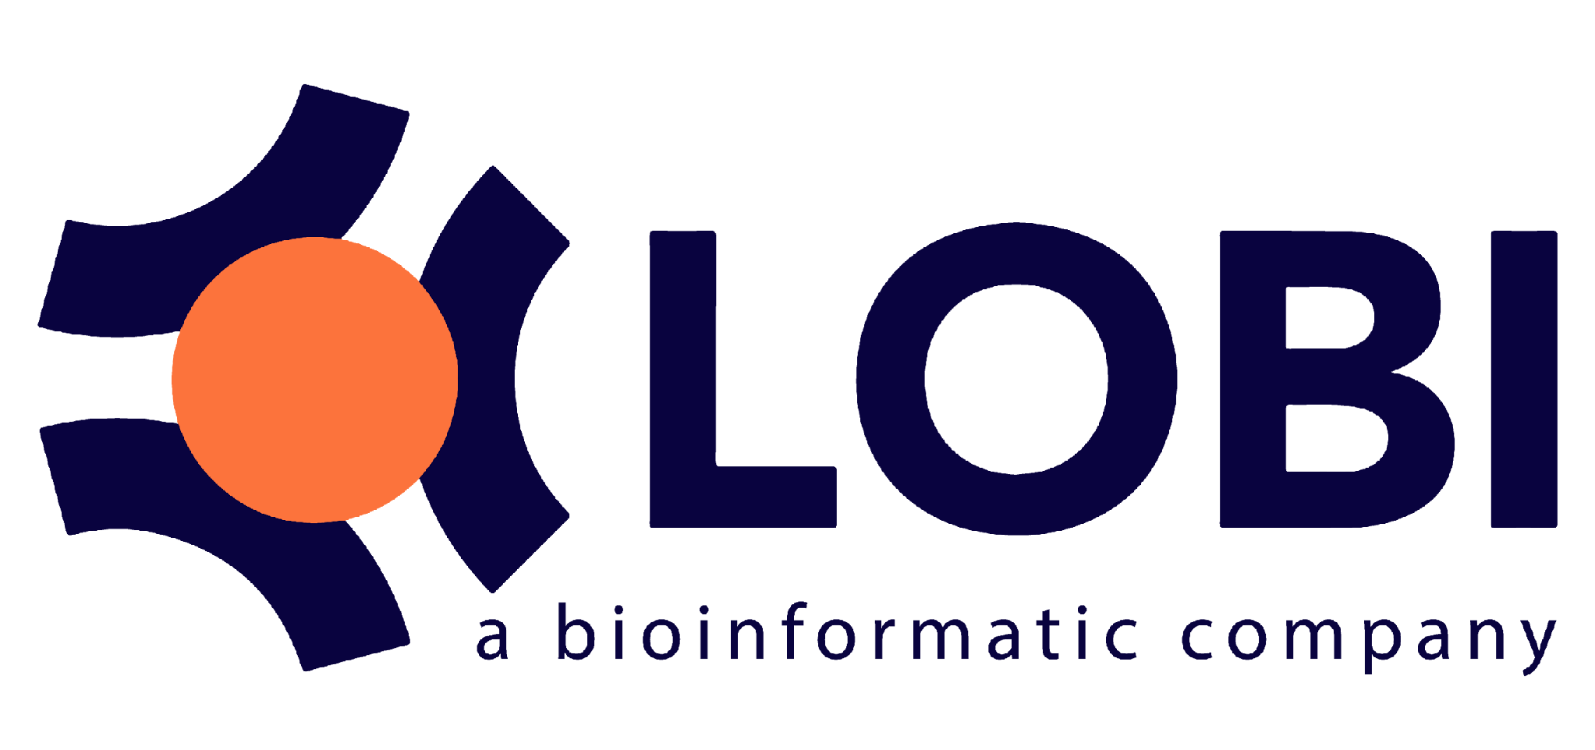

The 5th Vietnam School of Biology (VSOB5)

Mastering Agentic AI in Bioinformatics: From Insight to Impact

ICISE, 07 Science Avenue, Quy Nhon Nam Ward, Gia Lai, Vietnam
Oct 29th -31st, 2026

PROGRAMME

Day 1: Thursday, Oct. 29th, 2026
07:30 – 8: 30 | Course registration and informal introductions | ICISE
08:30 – 9:00 | Welcome address  Introduction of trainers and participants, group photo | Dr. Tran Thanh Son,  Vice Director, ICISE  Pricipal, Quang Trung University  Assoc.Prof.Dr. Nguyen Bao Quoc,  Nong Lam University, HCMC
09:00 – 09:15 | Introduction of course work and practical sessions | Dr. Cuong Nguyen,  LOBI Ltd.,  Institute of Information Technology, VAST
09:15 – 10:00 | Keynote talk 1: Toward sustainable life sciences: privacy preserving AI and multimodal data integration | Dr. Tran Thuong Van Du  Swiss Institute of Bioinformatics. Adjunct Professor, University of Science, Vietnam National University, Ho Chi Minh City
10:00 - 10:20 | Tea break
10:20 – 11:15 | Lecture: Agentic Bioinformatics in Practice: From Raw Data to Biological Insight with AI Agents | Dr. Nguyen Cuong  LOBI Ltd.,  Institute of Information Technology, VAST
11:15 – 12:00 | Keynote talk 2: From biostatistics to Agentic AI in bioinformatics | Dr. Bui Van Thach  FIT, University of Science, Vietnam National University, HCM City, Vietnam
12:00 – 13:30 | Lunch break | ICISE, Quy Nhon City
13:30 – 17:30 | Lecture: Agentic Bioinformatics in Practice: From Raw Data to Biological Insight with AI Agents | Dr. Nguyen Cuong  LOBI Ltd.,  Institute of Information Technology, VAST
Day 2: Friday, Oct. 30th, 2026
8:30-9:15 | Keynote talk 3: Triết học khoa học trong thời đại AI và công nghệ sinh học | Assoc. Prof. Dr. Nguyen Hoang Hai  Vietnam National University
9:15-11:30 | Case study challenge:  - Group Assignment: Participants divide into 5 groups to solve specific diverse Bioinformatics case studies.  - Hands-on Mentorship: Intensive group work with TAs and Tutors to build AI-driven solutions. | All participants
11:30 – 13:30 | Lunch break | ICISE, Quy Nhon City
13:30-14:00 | Talk: How to work with AI to run your dry lab | Thao My Nguyen  Founding Member, Head of Product Design, Business Development  Drylab, Inc.
14:00-14:20 | Participant Talks: Sharing from the Field | Moderator: Dr. Cuong Nguyen,  Presenters: Registered participants
 | Tea Break
14:30-17:30 | Case study challenge (cont') | All participants
 | Gala dinner | All participants
Day 3: Saturday, Oct 31st, 2026
8:30 - 09:00 | Keynote talk 4: "Quang di truyền" giải thưởng Nobel y học 2026 - bước tiến đột phá để "Hack" bão bộ: Sinh học là Phần cứng, AI là Phần mềm và Ánh sáng là Chìa khóa? | Assoc. Prof. Dr. Chu Dinh Toi  Dean of Faculty of Applied Science, International School, VNU
9:00 - 11:30 | Reporting & Awards  - Group Presentations : Teams present their findings and AI workflows.  - Evaluation: Final assessment by the board of experts. | Moderator: Dr. Cuong Nguyen,  Presenters: elected leaders
11:30-12:30 | Closing Ceremony: Awarding the VSOB5 Championship. | All participants

